Experiment No: 10
Explore and implement Autoencoders for image denoising

1. Dataset Source
MNIST Dataset
Source: Built-in dataset in TensorFlow/Keras
Link: https://keras.io/api/datasets/mnist/

2. Dataset Description
The MNIST dataset contains grayscale images of handwritten digits.
- Number of Instances: 70,000
- Image Size: 28 × 28 pixels

🔹 Features:
- Pixel values (0–255)

🔹 Target:
- In Autoencoder, input = output
- Model learns to reconstruct clean images

3. Mathematical Formulation

🔹 What is Autoencoder?
Autoencoder is an unsupervised neural network used for:
- Feature learning
- Data compression
- Noise removal

🔹 Architecture
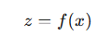
Autoencoder has 3 main parts:

1. Encoder

2. Latent Space
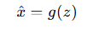
Bottleneck layer (important for learning features)

3. Decoder

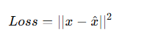
Reconstructs original input

🔹 Loss Function

Minimize difference between:
- Original image
- Reconstructed image

🔹 Denoising Autoencoder
Input: Noisy image
Output: Clean image
Model learns to:
- Remove noise
- Preserve important features

🔹 Why Autoencoders Work?
- Learn hidden patterns
- Capture important features
- Ignore noise

4. Algorithm Limitations
- Requires large data
- May learn identity function
- Overfitting risk
- Sensitive to architecture

5. Methodology / Workflow
- Load MNIST dataset
- Normalize images
- Add noise to images
- Build autoencoder
- Train model
- Predict denoised images
- Visualize results

6. Performance Analysis
- Compare:
  - Noisy images
  - Reconstructed images
- Metrics:
  - Mean Squared Error (MSE)
Better model → cleaner output

7. Hyperparameter Tuning
- Number of layers
- Number of neurons
- Noise level
- Epochs

Code:
# ================= STEP 1: IMPORT =================

import numpy as np

import matplotlib.pyplot as plt

from tensorflow import keras

from tensorflow.keras import layers

# ================= STEP 2: LOAD DATA =================

(x_train, _), (x_test, _) = keras.datasets.mnist.load_data()

# ================= STEP 3: NORMALIZE =================

x_train = x_train / 255.0

x_test = x_test / 255.0

# ================= STEP 4: ADD NOISE =================

noise_factor = 0.5

x_train_noisy = x_train + noise_factor * np.random.normal(size=x_train.shape)

x_test_noisy = x_test + noise_factor * np.random.normal(size=x_test.shape)

# Clip values

x_train_noisy = np.clip(x_train_noisy, 0., 1.)

x_test_noisy = np.clip(x_test_noisy, 0., 1.)

# ================= STEP 5: BUILD AUTOENCODER =================

model = keras.Sequential([

layers.Flatten(input_shape=(28,28)),

layers.Dense(128, activation='relu'),

layers.Dense(64, activation='relu'),

layers.Dense(128, activation='relu'),

layers.Dense(28*28, activation='sigmoid'),

layers.Reshape((28,28))

])

# ================= STEP 6: COMPILE =================

model.compile(

optimizer='adam',

loss='mse'

)

# ================= STEP 7: TRAIN =================

model.fit(

x_train_noisy, x_train,

epochs=5,

batch_size=256,

validation_split=0.2

)

# ================= STEP 8: PREDICT =================

decoded = model.predict(x_test_noisy)

# ================= STEP 9: VISUALIZE =================

n = 5

plt.figure(figsize=(10,4))

for i in range(n):

# Noisy

ax = plt.subplot(2, n, i+1)

plt.imshow(x_test_noisy[i], cmap='gray')

plt.title("Noisy")

plt.axis("off")

# Denoised

ax = plt.subplot(2, n, i+n+1)

plt.imshow(decoded[i], cmap='gray')

plt.title("Denoised")

plt.axis("off")

plt.show()

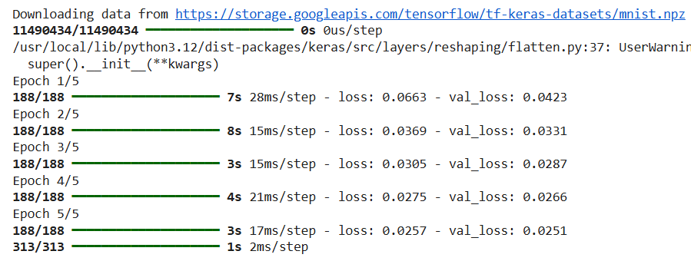
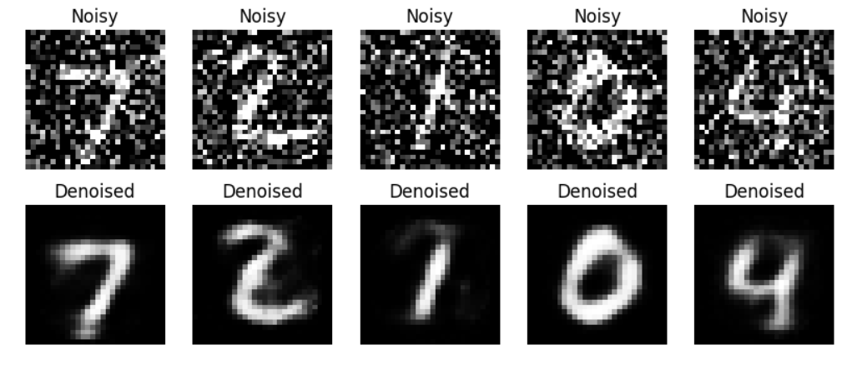
Conclusion:
Autoencoders were successfully implemented for image denoising. The model learned to remove noise from images and reconstruct clean outputs, demonstrating the effectiveness of deep learning in image processing tasks.

